# How to enable CORS(Cross-origin resource sharing) in ASP.NET Core

## Introduction

CORS(Cross-origin resource sharing) is a mechanism that allows restricted resources (e.g. fonts) on a web page to be requested from another domain outside the domain from which the resource originated. A web page may freely embed images, stylesheets, stylesheets, scripts, iframes, videos. Certain “cross-domain” requests, notably AJAX requests, however are forbidden by default by the same-origin security policy.

CORS defines a way in which a browser and server can interact to determine whether or not it is safe to allow the cross-origin request. It allows for more freedom and functionality than purely same-origin requests, but is more secure than simply allowing all cross-origin requests. It is a recommended standard of the [W3C](https://en.wikipedia.org/wiki/World_Wide_Web_Consortium).

This sample demonstrate how to enable CORS in ASP.NET Core.

## Sample prerequisites

* .NET Core 1.0 or later version(s). [[.NET Core + Visual Studio tooling](http://go.microsoft.com/fwlink/?LinkID=798306)]
* Microsoft Visual Studio 2015 update3 or above. [[Visual Studio 2015](https://www.visualstudio.com/en-us/visual-studio-homepage-vs.aspx)]

## Building the sample

**Setup the client side web site.**

* Open the Internet Information Services (IIS) Manager.
* Select default web site, and click Basic Settings button.

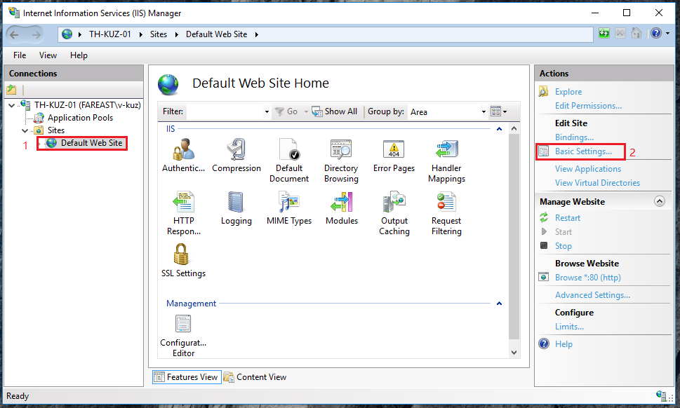

* Set the default web site source folder as the sample folder.

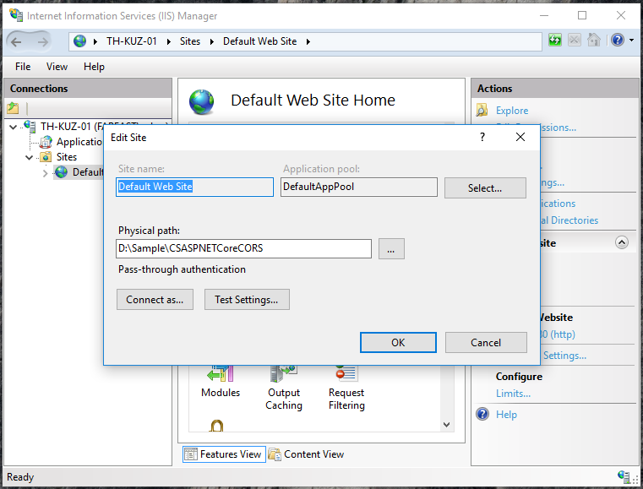

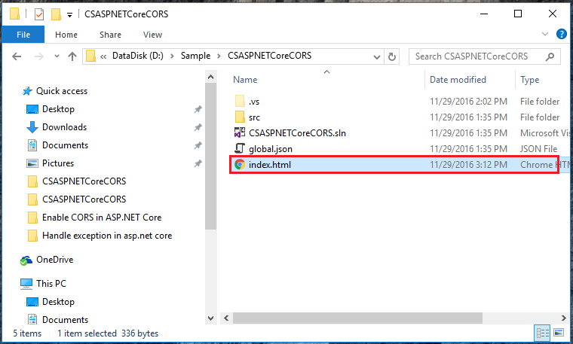

* Open the sample solution “**CSASPNETCoreCORS**” using Visual Studio.
* Right click the project “**CSASPNETCoreCORS**” and select Restore packages.

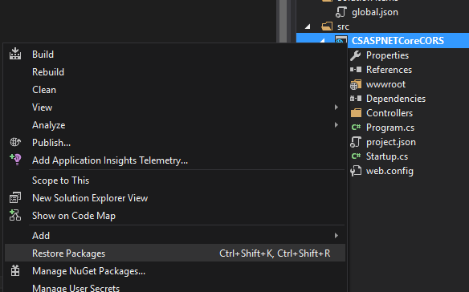

* Press **F6 Key** or select **Build -> Build Solution** from the menu to build the sample.

## Running the sample

* Open the Sample solution using Visual Studio, Then press **F5 Key** or select **Debug -> Start Debugging** from the menu.
* When the web application is running, you will see a 404 result.

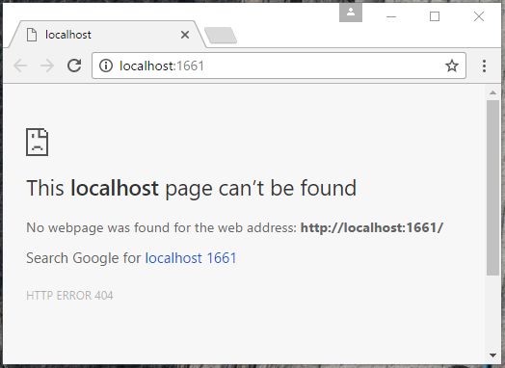

* Ignore this, and go to the <http://localhost>. You will see the screen.

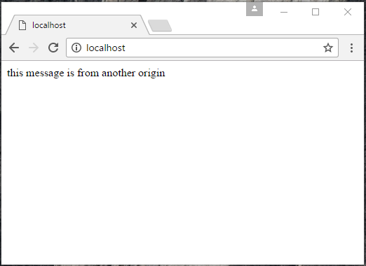

This page will post a request the <http://localhost:1661>, and print the result to the page.

* Open the debug tool in the browser, and switch the Network tab, then refresh this page. You will see the network request in the Network table.

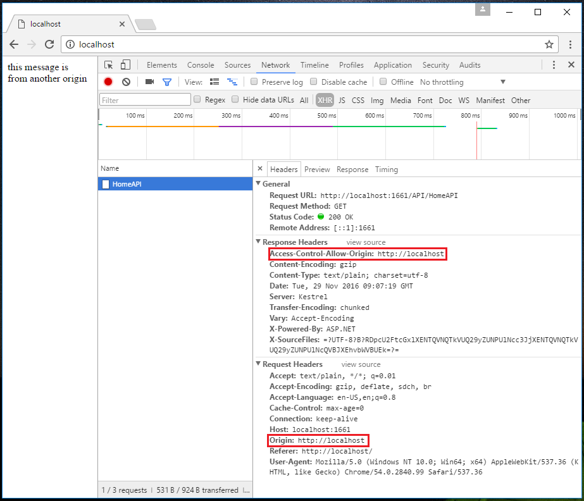

The “Origin” header gives the domain of the site that is making the request, if the server allows the request, it sets the Access-Control-Allow-Origin header.

If the response does not include the Access-Control-Allow-Origin header, the AJAX request fails. Specifically, the browser disallows the request. Even if the server returns a successful response, the browser does not make the response available to the client application.

## Using the code

At Startup.cs

public void ConfigureServices(IServiceCollection services)

{

#region case 1:

//services.AddCors();

#endregion

#region case 2,3:

services.AddCors(options =>

{

options.AddPolicy("AllowSpecificOrigin", builder =>

{

builder.WithOrigins("http://localhost", "https://www.microsoft.com");

});

//options.AddPolicy("AllowAllOrigins", builder =>

//{

// builder.AllowAnyOrigin();

// // or use below code

// //builder.WithOrigins("*");

//});

});

#endregion

services.AddMvc();

}

public void Configure(IApplicationBuilder app, IHostingEnvironment env, ILoggerFactory loggerFactory)

{

#region case 1:

//app.UseCors(builder => builder.WithOrigins("http://localhost"));

//app.Run(async (context) =>

//{

// await context.Response.WriteAsync("Hello World!");

//});

#endregion

#region case 2:

//app.UseCors("AllowSpecificOrigin");

//app.Run(async (context) =>

//{

// await context.Response.WriteAsync("Hello World!");

//});

#endregion

#region case 3:

//see the controller attribute

//like [EnableCors("AllowSpecificOrigin")]

#endregion

app.UseMvc();

}

At HomeAPIController.cs

//[EnableCors("AllowSpecificOrigin")]

[Route("api/[controller]")]

public class HomeAPIController : Controller

{

[EnableCors("AllowSpecificOrigin")]

[HttpGet]

public string Get()

{

return "this message is from another origin";

}

[DisableCors]

[HttpPost]

public string Post()

{

return "this method can't cross origin";

}

}

In another website page.

<script>

$.get("http://localhost:1661/API/HomeAPI", {}, function (data) {

console.log(data);

document.write(data);

}, "text");

</script>

## More information

Enabling Cross-Origin Requests(CORS)

<https://docs.microsoft.com/en-us/aspnet/core/security/cors>